

**NETWORKING & SYSTEM ADMINISTRATION LAB**

**Experiment No.: 2**

**Aim**

Familiarize the hardware components

**Procedure**

Computer hardware includes the physical parts of a computer, such as the case, central processing unit (CPU), random access memory (RAM), monitor, mouse, keyboard, computer data storage, graphics card, sound card, speakers and motherboard.

1.mouse

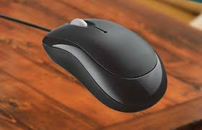

A mouse is a hardware input device that is used to move the cursor or pointer on computer screens.

It can also be used to run computer programs, select items in a graphical user interface, and manipulate objects in the computer world.

Some common examples of how it can be used are clicking on buttons, scrolling up and down the screen, selecting files, opening folders, and so on.

### 

### 

### 

### 

### 2. Keyboard

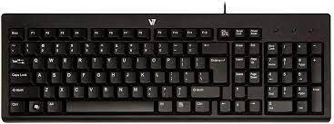

A keyboard is an input device that you use to enter data into a computer.

It's also called the input device for your computer. Keyboards are used with PCs, laptops, tablets, and other devices.

There are many different types of keyboards, but the most common one is the QWERTY keyboard.

A QWERTY keyboard has all the letters in alphabetical order on it.

This is different from some other types of keyboards, like Dvorak or Colemak keyboards.

For example, these keyboards have keys arranged differently than what you’re used to seeing on a QWERTY keyboard.

And that means that typing on these keyboards will feel like typing in another language at first! But don’t worry - once you get accustomed to it, it feels natural

### 3. Monitor

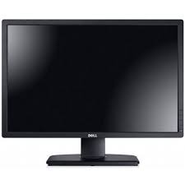

Personal computers use a monitor to display data, run the software, and interact with the user.

A monitor is an electronic visual display that connects to your computer or laptop.

It is used for displaying images, text, videos, games, web pages, and more.

Monitors are available in different sizes depending on the needs of the person using them.

The most common types of monitors are CRT (cathode ray tube), LCD (liquid crystal display), and LED (light-emitting diode).

### 4. CPU ( Central Processing Unit )

A CPU, or central processing unit, is the brain of a computer. The CPU processes information and runs programs.

It functions as a control unit that executes programs according to instructions in its program memory.

The CPU contains elements such as registers, an arithmetic logic unit (ALU), and control logic for sequencing instructions.

### 

### 

### 

### 

### 

### 

### 

### 

### 5. RAM Memory

A computer's RAM is a type of computer memory that stores information so the CPU can access it directly.

Computer systems use main memory to store both data and programs.

The more RAM you have, the more data your system can process at one time.

This will lead to more efficient operations on your computer, which translates into better performance for the user.

### 6. ROM Memory

ROM stands for a type of memory chip that can be read from but not written to.

In other words, it's a form of data storage that can't be changed after being programmed.

It's sometimes called "non-volatile" memory because the stored information will remain even when not powered up or in use.

ROM is often used to store a computer's basic start-up instructions and certain types of data, such as your car's onboard computer system and a calculator's data tables

### 

### 

### 

### 

### 

### 

### 7. IO System

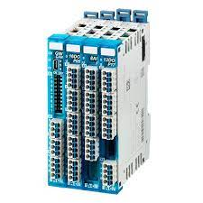

The IO system is the set of devices that are used to access data.

There are three major parts of the IO system: input, output, and storage.

Input devices, also called input peripherals, are typically what data is first inputted into the computer.

Output devices are where data is displayed. Storage devices store data so it does not need to be present in memory or processed by a CPU.

### 8.Motherboard

The motherboard is the backbone of our computer system. It's the central processing unit or CPU.

It connects all the other components, like memory and graphics card, to the power supply.

The motherboard is where all the wires are plugged in and it's also where you place your RAM, which is your computer's working memory.

The motherboard is what makes one machine different from another.

Motherboards are made up of tiny transistors that control the flow of electricity through copper tracks on their surface.

These transistors are called Integrated Circuits or ICs for short

### 

### 9.Hard Disk Drive

A hard disk drive is a piece of hardware inside a computer that stores information.

It's used to store software and data in a safe place, which can be accessed when needed.

With magnetic storage, there are no moving parts - unlike a CD or DVD player in which you need to move a disk in order to access data.

You can think of it as "a closet" where all your stuff is stored safely.

As long as you have power, you can get to your things when you need them.

## 10.Power Supply Unit

A power supply unit, commonly abbreviated as PSU, does more than just supply your computer with power. It is the point where power enters your system from an external power source and is then allocated by the motherboard to individual component hardware. Not all power supplies are made equally however, and without the right wattage PSU your system will fail to work.

### 11.Optical Drive

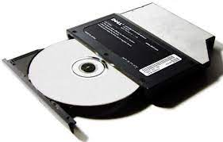

Optical Drives are used in PCs to read and write CDs and DVDs.

The optical drive reads the data from the disc, which can then be transformed into a digital file that is readable by the computer.This makes it easy to backup files, play music or movies, or copy data from one disc to another.

The term "CD" refers to Compact Discs, which are the most common type of optical drive on modern computers.They are often used for installing software on your computer, moving data between computers, or writing new programs.

### 

### 

### 

### 12. External Ports

External ports are used to connect your computer to other devices like printers and speakers, among many others.

However, not all external ports are the same. You’ll find different types of ports on laptops and desktops that allow you to use them in different ways.

### 13. Video Display Controller

Video display controllers (sometimes shortened to VDC) are circuits found in video cards, which control the video output of the computer.

The controller is responsible for formatting the data that is sent to the monitor or TV.

Video display controllers can be implemented by either an onboard circuit on the motherboard or a separate card that connects to the motherboard through a slot.

### 13. CPU Fan

The CPU fan in the computer is a very important component for your PC.

If your CPU fan is not working correctly, your computer will be overheating and it may cause damage to other components.

The CPU fan helps cool the CPU and other internal parts of the computer.

It also provides negative pressure and removes dust and debris from the inside.

14.modem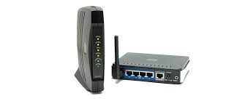

The sole purpose of the modem is to provide you with internet access. If you were to only have one internet-connected device with an Ethernet port (such as a desktop computer), you could connect the modem directly to your computer with no need for a router.

15.network card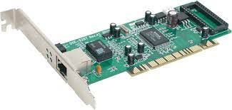

The network card operates as a middleman between a computer and a data network. For example, when a user requests a webpage, the computer will pass the request to the network card, which converts it into electrical impulses.